Alt/Cuntas 2008 (15 Líne/90-100 focal)
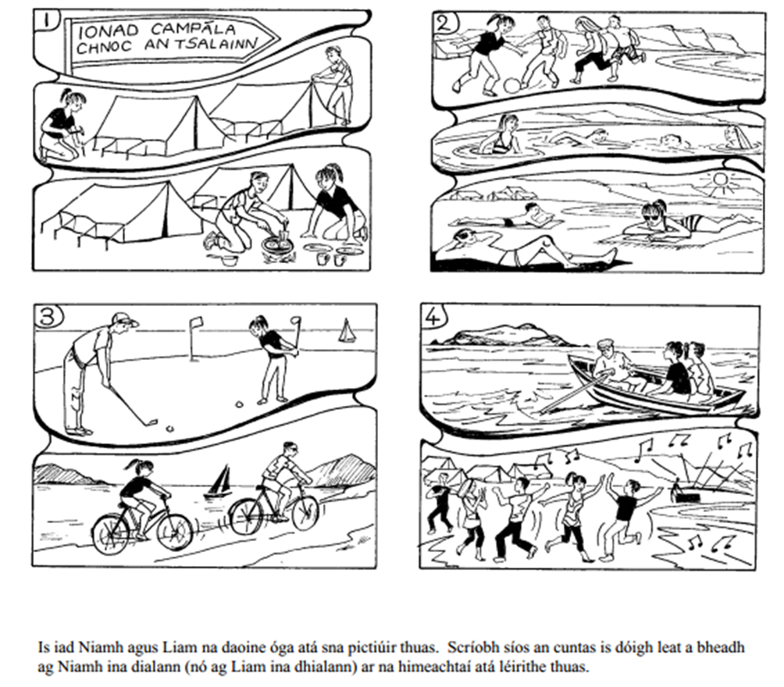

Aistrigh na habairtí seo a leanas bunaithe ar na pictiúir thuas
(Translate the following sentences based on the above pictures)

Pictiúr 1:
One day, I met with Niamh at the campsite.
__________________________________________________________________________________
I put the tent up
__________________________________________________________________________________
I made breakfast and we ate eggs
__________________________________________________________________________________
Pictiúr 2:
After a while, I started playing football on the beach
____________________________________________________________________________________________________________________________________________________________________
I jumped in the sea, me & Niamh went swimming and I lay under the sun
__________________________________________________________________________________
__________________________________________________________________________________
The weather was lovely
__________________________________________________________________________________
Pictiúr 3:
We went playing golf and then cycling beside the sea.
____________________________________________________________________________________________________________________________________________________________________
The craic was ninety
__________________________________________________________________________________
Pictiúr 4:
At 6 o’ clock we went sailing for a while and then I heard Avicci music on the beach
______________________________________________________________________________________________________________________________________________________________________________________________________________________________________________________
Everyone started dancing and we had a great disco
____________________________________________________________________________________________________________________________________________________________________

