Alt/Cuntas 2013 (15 Líne/90-100 focal)
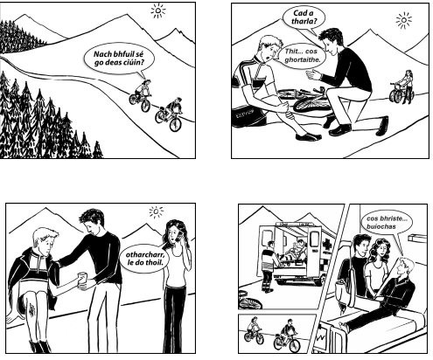
Is tusa Nuala nó Seán, duine de na daoine óga atá sna pitctiúit thíos. Scríobh síos an scéal atá léirithe sa tsraith pictiúr. Is tusa atá ag insint an scéil.
Translate the following sentences. (40 marc)

Pictiúr 1:
One day, the sun was shining and me and Seán went cycling in the mountains.
______________________________________________________________________________________________________________________________________________________
It was nice and quiet and the craic was ninety.
______________________________________________________________________________________________________________________________________________________

Pictiúr 2:
Then, we saw a man on the road.

He fell from his bike and his leg was injured.
______________________________________________________________________________________________________________________________________________________
Pictiúr 3:
Seán got water for him and he put a coat on him.
___________________________________________________________________________
His leg was bleeding.
___________________________________________________________________________
I rang the ambulance.
___________________________________________________________________________
Pictiúr 4:
After a while, the ambulance came.
___________________________________________________________________________
The doctor put the man in the ambulance.
______________________________________________________________________________________________________________________________________________________
Me and Seán left and we went to the hospital.
______________________________________________________________________________________________________________________________________________________
The man said “I broke my foot, thanks be to God and thank you very much”.
_________________________________________________________________________________________________________________________________________________________________________________________________________________________________

