Sraith Pictiúir – Teastas Sóisearach – Dul Siar Iomlán (30 marc)
You will be randomly asked one of the 5 picture stories. Try to include 3/4 sentences per picture
.
Sraith Pictiúr 1:
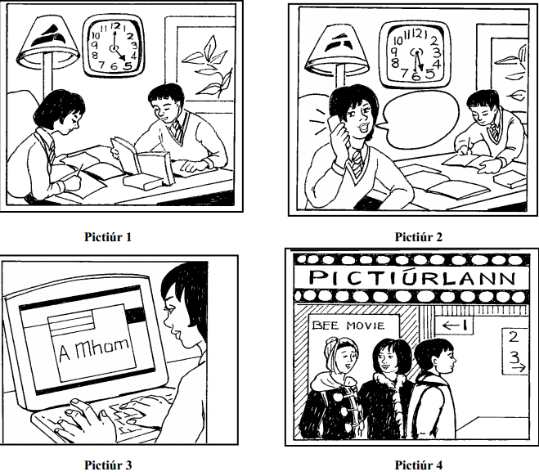

Sraith Pictiúr 1:

Pictiúr 1:
- Tá Ciara agus Conor sa seomra suí. (Ciara and Conor are in the sitting room)
- Tá clog ar an mballa agus tá sé a cúig a chlog (There is a clock on the wall it is 5 o’clock)
- Tá Conor ag léamh leabhair. (Conor is reading a book)
- Tá Ciara ag scríobh. (Ciara is writing)
- Tá lampa sa chúinne. (There is a lamp in the corner)
- Tá pictiúr ar an mballa. (There is a picture on the wall)
Pictiúr 2:
- Anois, tá sé leathuair tar éis a cúig. (Now, it is half 5)
- Tá Ciara agus Conor fós sa seomra suí. (Ciara and Conor are still in the sitting room)
- Tá Conor ag scríobh ach tá Ciara ag caint ar a fón póca. (Conor is writing but Ciara is talking on her mobile phone)
- Tá a hobair bhaile críochnaithe. (Her homework is finished)
Pictiúr 3:
- Anois, tá Ciara sa seomra staidéir. (Now, Ciara is in the study)
- Tá sí ar an ríomhaire. (She is on the computer)
- Tá sí ag scríobh ríomhphoist chuig a Mam. (She is writing an email to her Mam)
- Ceapaim go bhfuil sí ag dul amach.(I think she’s going out)
- Tá áthas uirthi. (She is happy)
Pictiúr 4:
- Tar éis tamall, téann siad go dtí an phictiúrlann. (After awhile, they go to the cinema)
- Tá a Mam in éineacht leo anois. (Their Mam is with them now)
- Tá ‘Bee Movie’ ar siúl. (Bee Movie is on)
- Tá siad ar bís. (They are excited)
- Tá an aimsir fuar agus tá siad ag caitheamh cótaí. (The weather is cold and they are wearing coats)

Sraith Pictiúr 2:

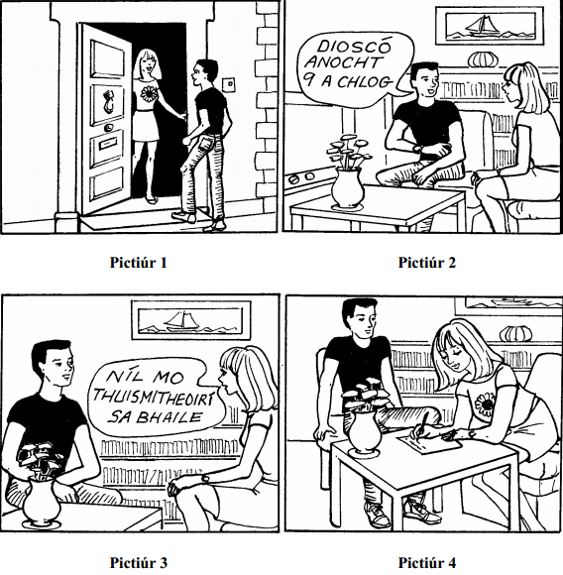

Sraith Pictiúr 2:
Pictiúr 1:
- Cnagann Liam ar an doras. (Liam knocks on the door)
- Agus osclaíonn Máire é. (And Máire opens it)
- Tá an Liam taobh amuigh den teach. (Liam is outside the house)
- Tá sé ag caitheamh t-léine dubh. (He is wearing a black t-shirt)
- Tá bláth ar t-léine Mháire. (There is a flower on Máire’s t-shirt)
- Tá áthas orthu. (They are happy)
Pictiúr 2:
- Anois, tá siad ag suí sa seomra suí. (Now, they are sitting in the sitting room)
- Tá teilifís sa chúinne. (There is a tv in the corner)
- Tá bláthanna ar an mbord agus pictiúr ar an mballa. (There are flowers on the table and a picture on the wall)
- Tá bád sa phictiúr. (There is a boat in the picture)
- “Tá dioscó ar siúl anocht ar a naoi a chlog” arsa Liam (“There is a disco on tonight at 9 o clock)
Pictiúr 3:
- Tá a lán leabhair ar an seilf. (There are lots of books on the shelf)
- Tá Máire ag caitheamh sciorta. (Máire is wearing a skirt)
- Tá siad ag caint faoin dioscó. (They are talking about the disco)
- “Níl mo thuismitheoirí sa bhaile” arsa Máire (My parents aren’t at home says Máire)
- Ach ba mhaith léi dul go dtí an dioscó (But she would like to go to the disco)
Pictiúr 4:
- Tá siad ag dul go dtí an dioscó. (They are going to the disco)
- Tá peann agus páipéar ag Máire mar tá sí ag scríobh nóta chuig a tuismitheoirí. (Máire has a pen & paper because she is writing a note to her parents)
- Tá Liam ag suí ar an gcathaoir. (Liam is sitting on the chair)
- Fágann siad nuair atá an nóta críochnaithe. (They leave when the note is finished)

Sraith Pictiúr 3:

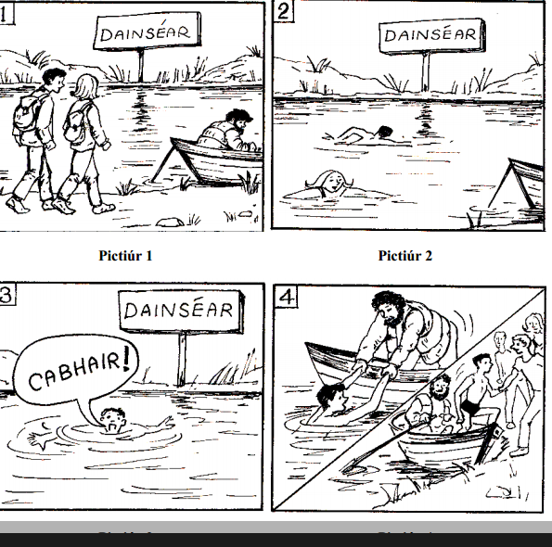

Sraith Pictiúr 3:
Pictiúr 1:
- Lá amháin, tá Killian & Niamh ag siúl cois abhainn. (One day, Killians & Niamh are walking beside the river)
- Tá siad ag caint. (They are talking)
- Tá fear ina shuí i mbád beag. (There is a man sitting in a little boat)
- Tá an fear ag iascaireacht. (The man is fishing)
- Tá fógra sa chúlra ach ní fheiceann said é. (There is a sign in the background but they don’t see it)
Pictiúr 2:
- Léimeann Killian & Niamh isteach san abhainn. (Killian & Niamh jump into the river)
- Tá siad ag snámh go sona sásta. (They are swimming happily)
- Deireann an fógra ‘dainséar’ ach ní léann siad é (The sign says ‘dainséar’ ach ní léann siad é.
- Tá áthas an domhain orthu. (They are delighted – the happiness of the world is on them)
Pictiúr 3:
- Ach go tobann tá Killian i ndainséar. (But suddenly Killian is in danger)
- Ní féidir leis Niamh a fheiceáil. (He can’t see Niamh)
- Tá eagla air anois. (He is frightened now)
- Tá sé ag screadáíl “cabhair” (He is screaming ‘help’)
Pictiúr 4:
- Tagann an fear ina bhád, buíochas le Dia! (The man comes in his boat, thanks be to God)
- Tugann sé cabhair do Killian (He helps Killian)
- Cuireann sé sa bhád é. (He puts him in the boat)
- Ar ais cois abhainn, tá grúpa mór daoine ann. (Back beside the lake, there is a big group of people)
- Tá siad ag gáire anois mar tá sé ag caitheamh fo-eadaí. (They are laughing now because he is wearing underwear)
- Tá Killian slán sábhailte anois. (Killian is safe & sound now)

Sraith Pictiúr 4:

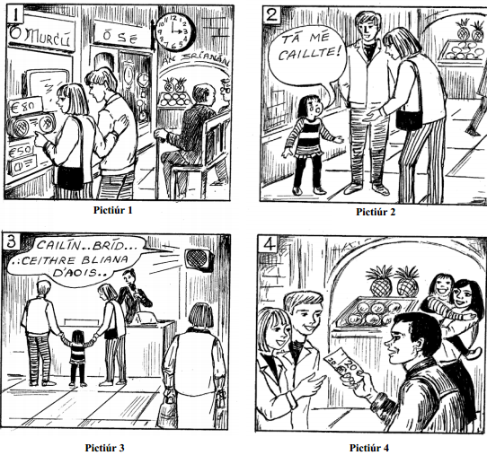

Sraith Pictiúr 4:
Pictiúr 1:
- Lá amháin, tá Clár agus Cormac ag siopadóireacht (One day Clare & Cormac are shopping)
- Tá sé a trí a chlog (It is 3 o’ clock)
- Tá siad in aice le siopa (They are beside a shop)
- Feiceann siad raidió san fhuinneog (They see a radio in the window)
- Tá an raidió ochtó euro (The radio is 80 euro)
Pictiúr 2:
- Ansin tá Clár agus Cormac ag siúl agus ritheann cailín beag suas (Now, Clare & Cormac are walking and a little girl runs up)
- Tá sí ag caoineadh (She is crying)
- “Tá mé caillte” arsa an cailín (“I’m lost” says the girl)
- Tá eagla uirthi (She is terrified)
Pictiúr 3:
- Lámh i lámh, siúlann siad an cailín go dtí an deasc (Hand in hand, the walk the girl to the desk)
- Deireann an bhean ag an deasc go bhfuil cailín caillte (The woman at the desk says/announces that the girl is lost)
- Bríd is ainm don chailín (Bríd is the girls name)
- Tá sí ceithre bliana d’aois (She is lost)
Pictiúr 4:
- Tagann a tuismitheoirí go dtí an deasc go tapaidh (Her parents come to the desk quickly)
- Tá áthas an domhain orthu go bhfuil an cailín óg ann (They are delighted that the little girl is there)
- Tugann an Daid fiche euro do Chlár agus Cormac (The Dad gives Clare & Cormac €20)
- Tá an cailín slán sabháilte anois, buíochas le Dia (The girl is safe & sound now, thanks be to God)
Sraith Pictiúr 5:

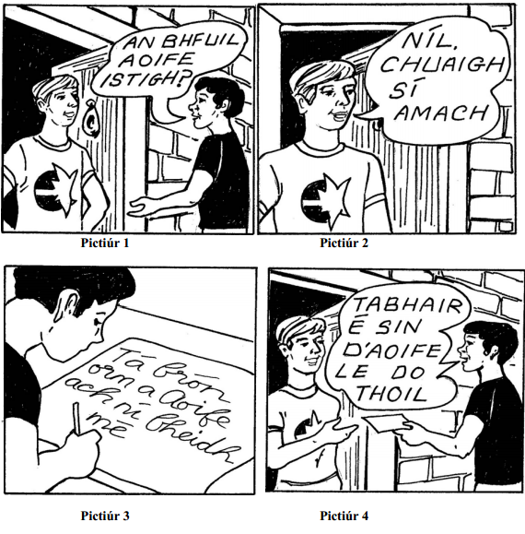

Sraith Pictiúr 5:

Pictiúr 1:
- Lá amháin, siúlann Liam go teach Aoife (One day, Liam walks to Aoife’s house)
- Cnagann sé ar an doras (He knocks on the door)
- Osclaíonn buachaill an doras. (A boy opens the door)
- Tá Liam ag caitheamh t-léine dubh agus tá gruaig dhubh aige freisin. (Liam is wearing a black t-shirt & he has black hair too)
- “An bhfuil Aoife istigh” arsa Liam (“Is Aoife in?” says Liam)
Pictiúr 2:
- Is buachaill chara Aoife é an buachaill (The boy is Aoife’s boyfriend)
- Eoin is ainm dó le gruaig fhionn álainn (Eoin is his name with lovely blonde hair)
- Níl Aoife sa theach (Aoife is not in the house)
- “Chuaigh sí amach” arsa Eoin (“She went out” says Eoin)
- Tá Eoin ag caitheamh t-léine bán le réalta (Eoin is wearing a white t-shirt with a star)
Pictiúr 3:
- Tá Liam croí bhriste mar tá buachaill chara ag Aoife (Liam is heartbroken because Aoife has a boyfriend)
- Suíonn sé síos le peann agus páipéar (He sits down with a pen & paper)
- Scríobhann sé nóta d’Aoife (He writes a note to Aoife)
- Deireann an nóta “tá brón orm….” (The note says “I’m sorry…”)
- Tá sé ag caoineadh taobh istigh (He is crying inside)
Pictiúr 4:
- Tugann Liam an nóta d’Eoin ag rá “tabhair é sin d’Aoife le do thoil” (Liam gives the note to Eoin saying “give that to Aoife please”)
- Tógann Eoin an nóta (Eoin takes the note)
- Siúlann Liam abhaile (Liam walks home)
- Agus tá Eoin an-shásta leis fhéin mar fuair sé an cailín (Eoin is delighted because he got the girl)

